Name: Rajdeep Sarkar
Roll: UG/02/BTCSECSF/2023/008
UDB END LAB
Members: Sessions:
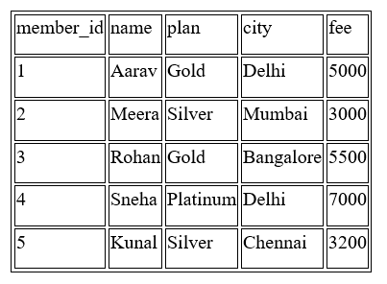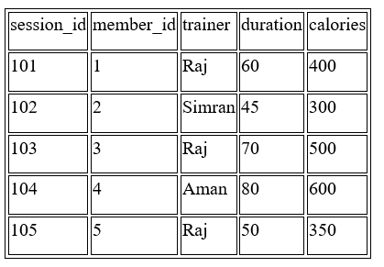
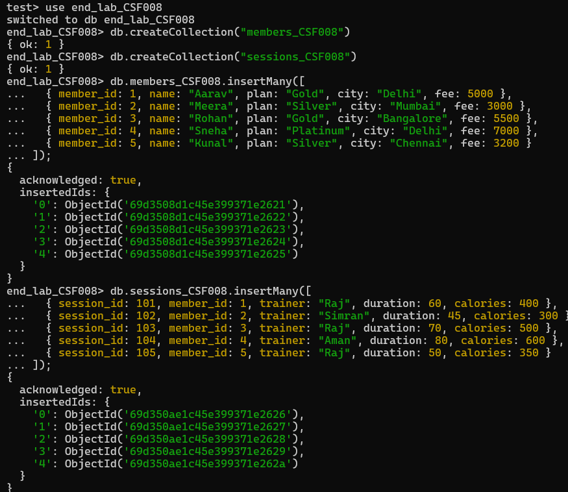

Q1. Display all members
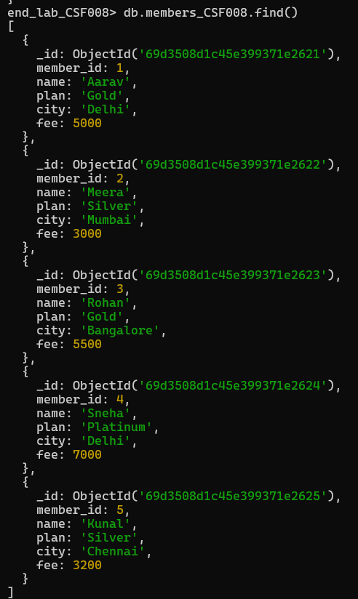
Q2. Show name and plan only
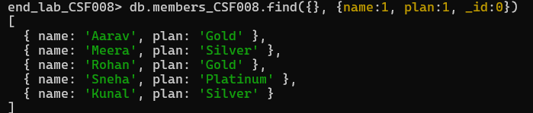
Q3. Find members from Delhi
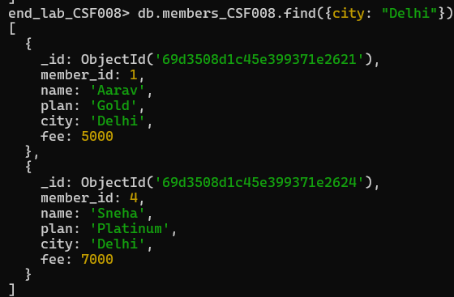
Q4. Find sessions with duration > 60
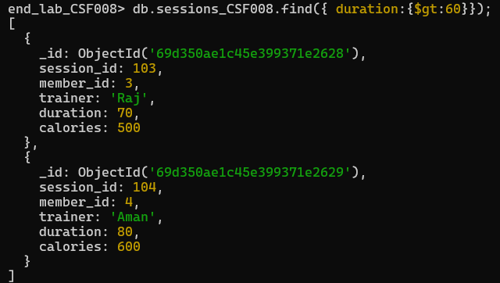
Q5. Sort members by fee descending
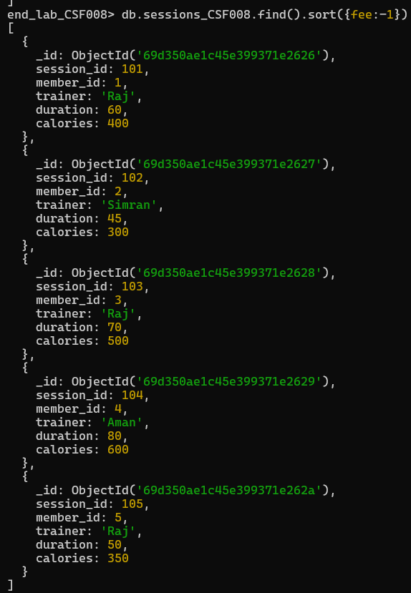
Q6. Update fee +500 for Gold members
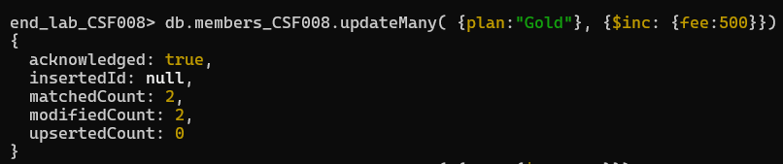
Q7. Delete members with fee < 3500
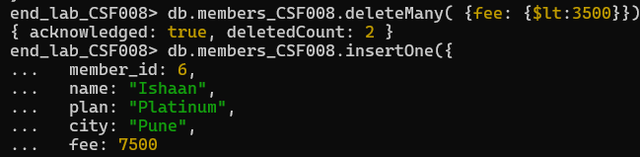
Q8. Insert a new member
Q9. Average fee per plan
Q10. Total calories burned per trainer
Q11. Maximum fee per city
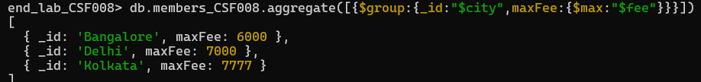
Q12. Count members per plan
Q13. Trainers with avg calories > 400
Q14. Total duration per member_id
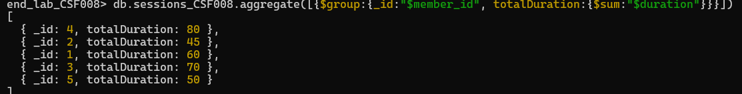

Q15. Join members with sessions
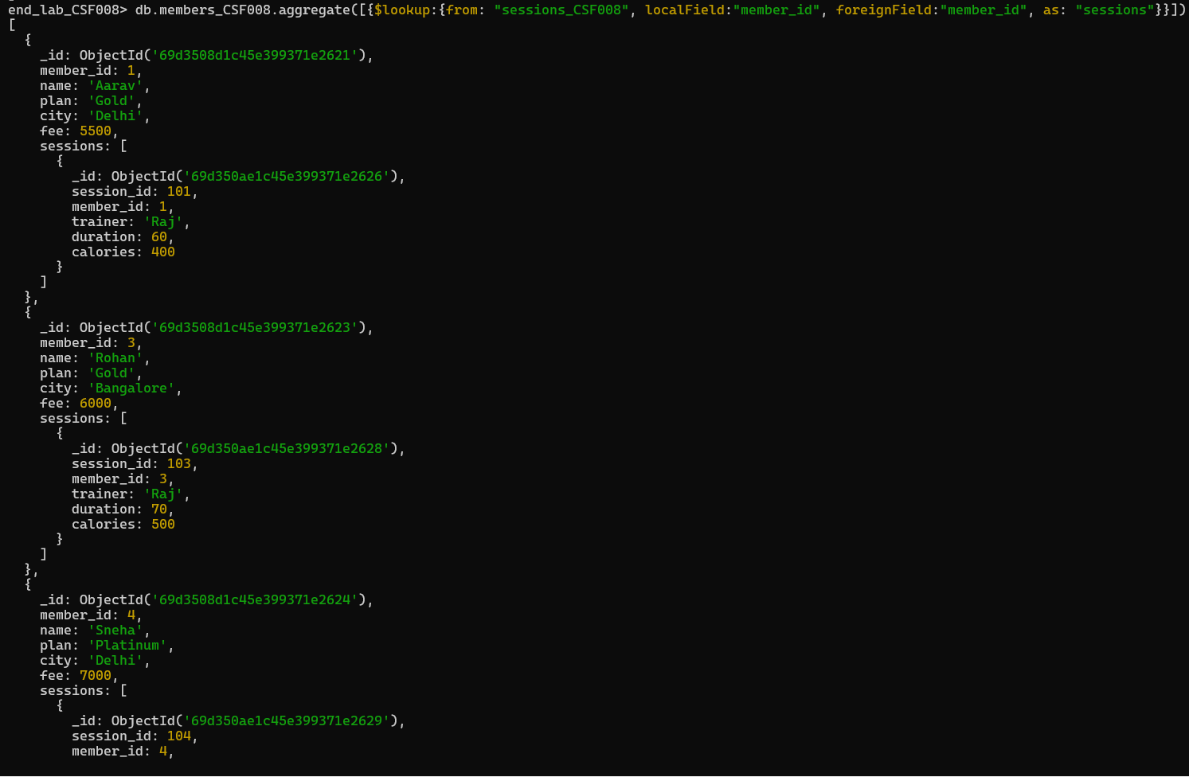
Q16. Show members who have sessions
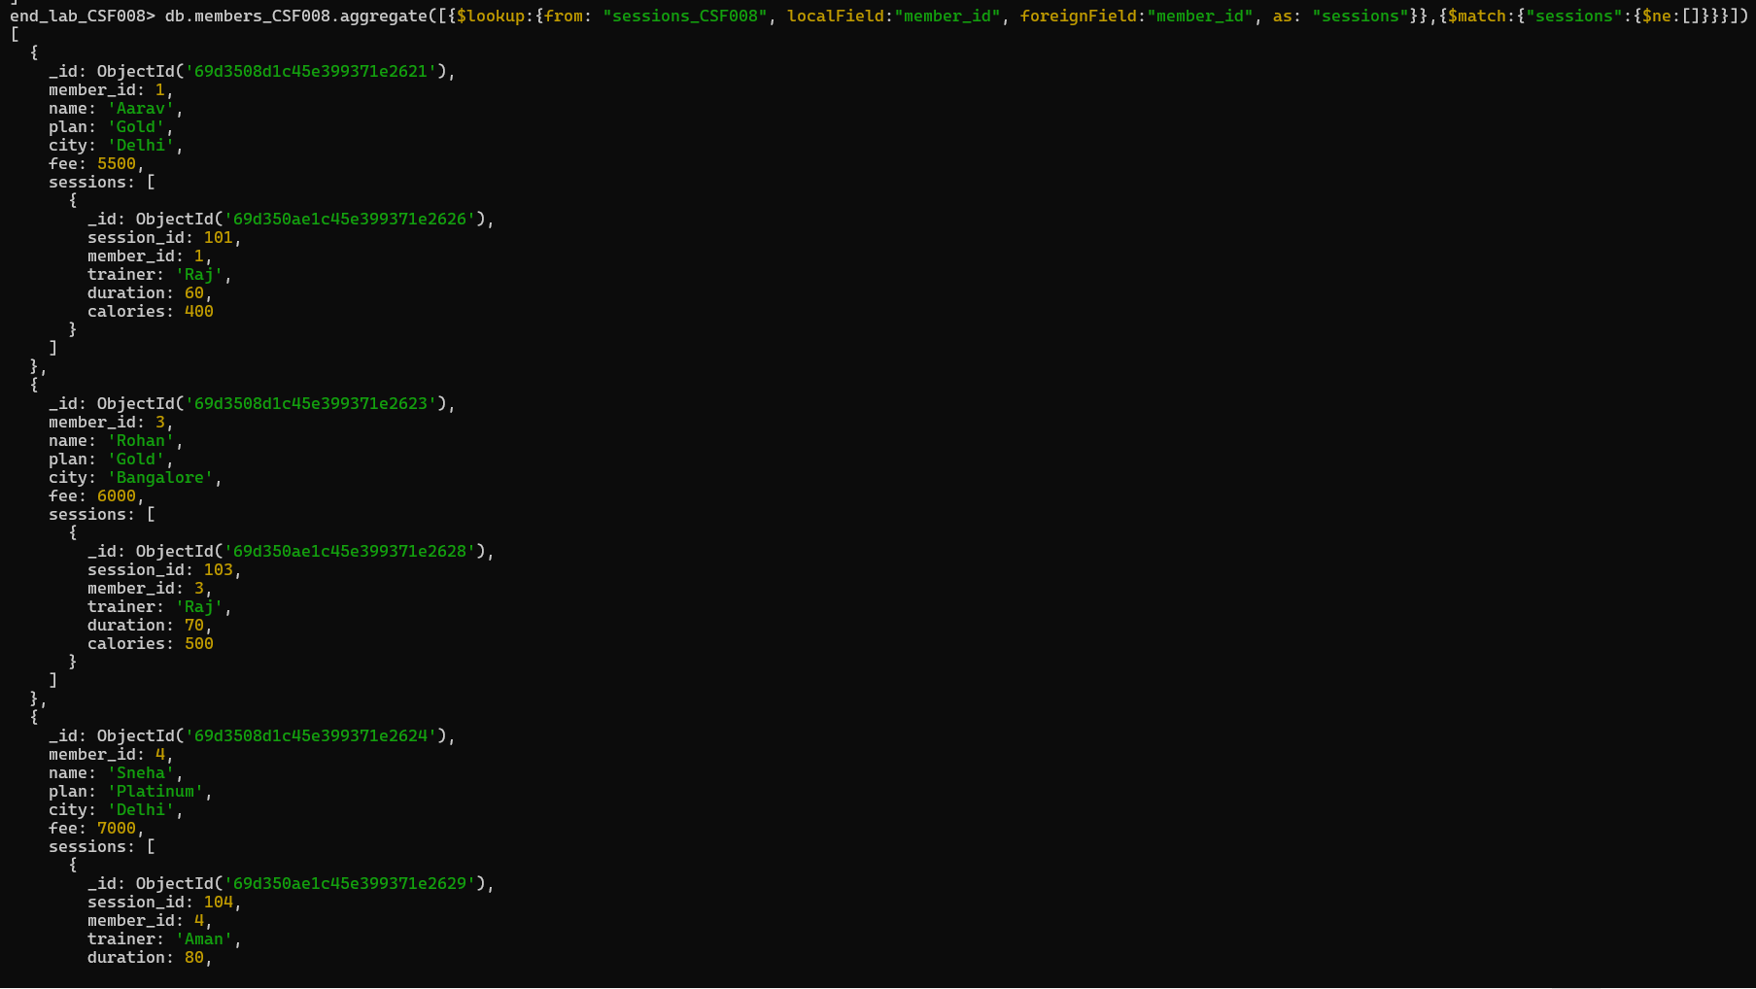
Q17. Create index on city
Q19. Create compound index on plan and fee
Q20. Display 2nd and 3rd highest fee members
